Northwind Data Manipulation Functions Exercise:

In this exercise, you will practice using data manipulation functions using the Northwind database.

Entity Relationship Diagram for Northwind:

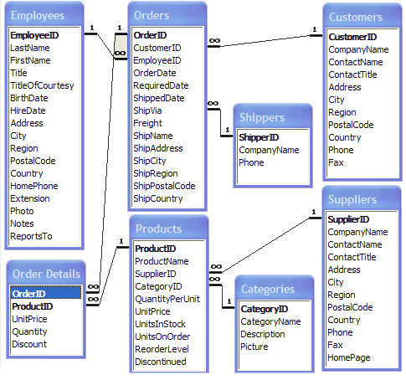

1. Create a report that shows the units in stock, unit price, the total price value of all units in stock, the total price value of all units in stock rounded down, and the total price value of all units in stock rounded up. Sort by the total price value descending.
2. You saw a report that returned the age of each employee when hired. That report was not entirely accurate as it didn't account for the month and day the employee was born. Fix that report, showing both the original (inaccurate) hire age and the actual hire age. The result will look like this. (Hint: try incorporating To_Days as a function, https://dev.mysql.com/doc/refman/5.7/en/date-and-time-functions.html)

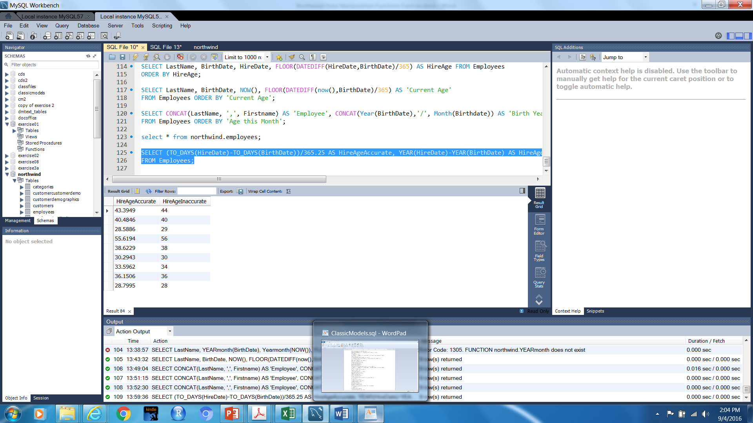

1. We need to know the current ages of the salesforce personnel current. Your report should look like this:

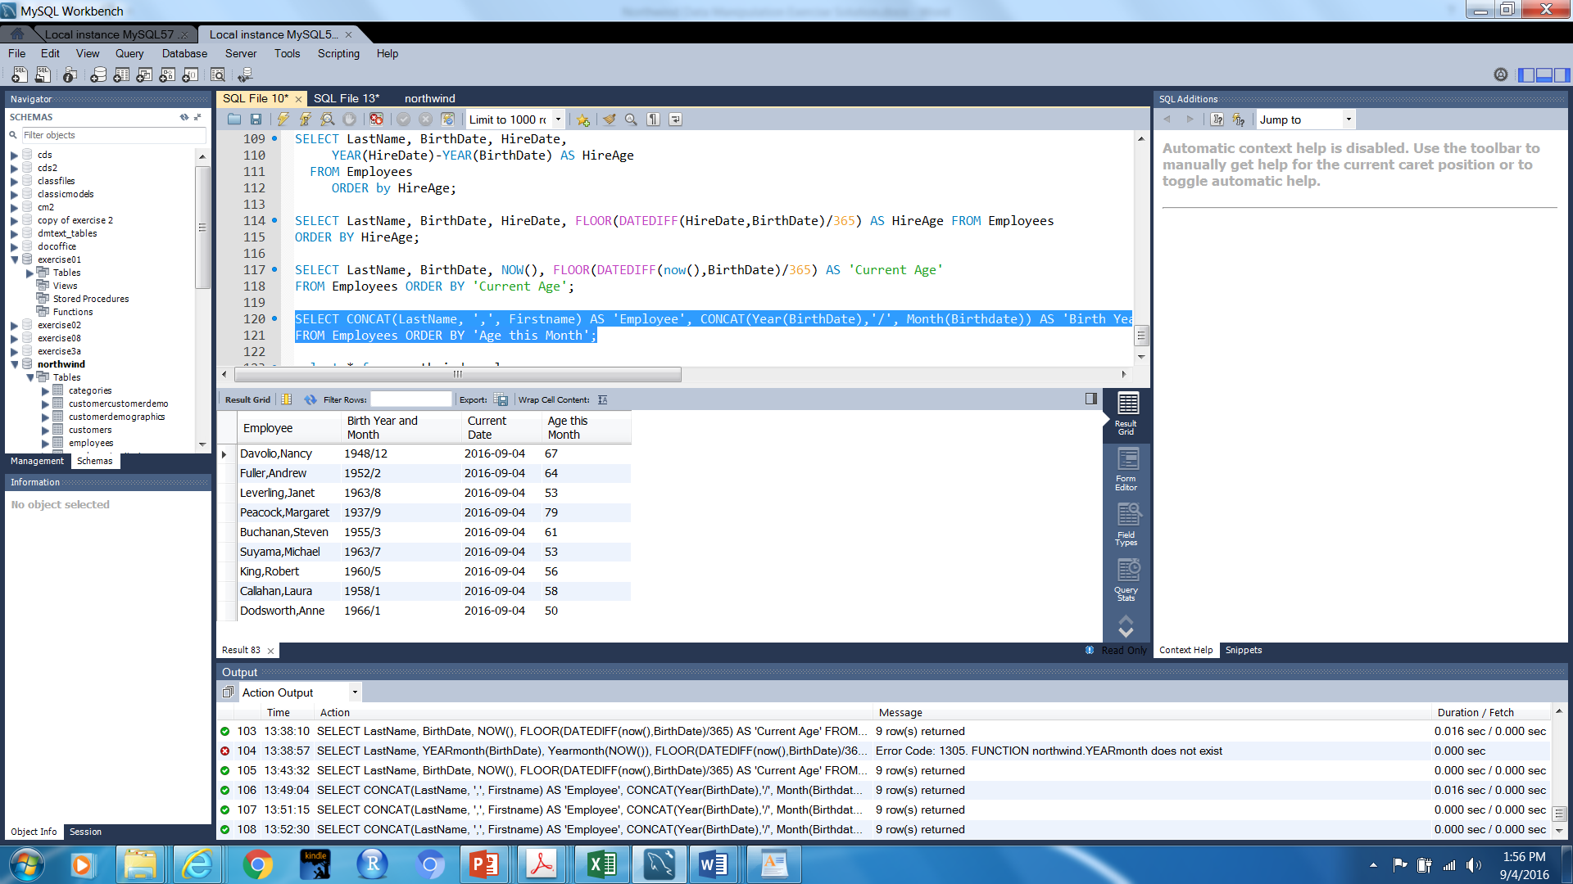

1. Find the Birth month for every employee. Research how to use DATE_FORMAT to display the month (https://dev.mysql.com/doc/refman/5.7/en/date-and-time-functions.html#function_date-format). The report should look like:

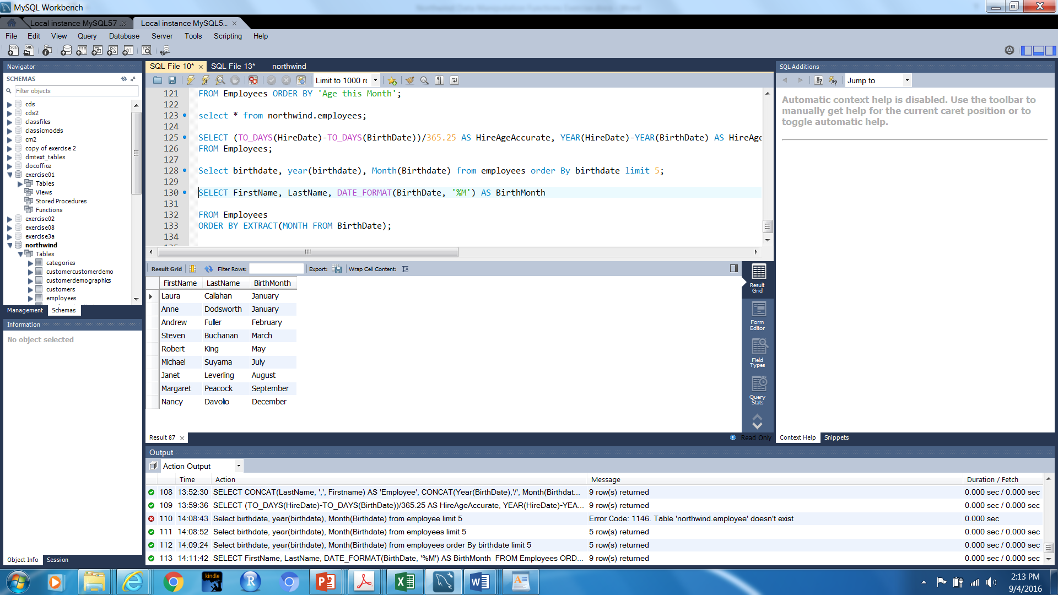

1. Create a report that shows the first and last names and birth month (as a string) for each employee born in the current month. Note: if the current month is April, June, October, or November, you should get no results. Research how to use EXTRACT in conjunction with the date current on your computer (https://dev.mysql.com/doc/refman/5.7/en/date-and-time-functions.html#function_extract)